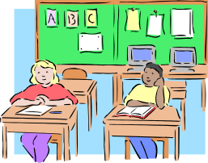

iPads and other tablets - resources

At Merewether PS we have 26 iPads which have been set up identically. They are not allocated to a class or teacher rather they form a school set from which teachers can sign out tablets for their classroom as required.

Our iPads have hundreds of free apps and at this stage we have not purchased apps.
DEC Sydney Region Trial information  Great presentation that details the technical issues around using iPads in the classroom.  PDF is on the ECT Blog  http://newcastleearlycareerteachers.wordpress.com/ | 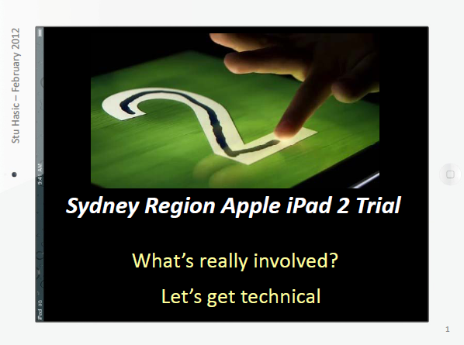
Merewether PS staff meeting – 3 apps in 3 minutes  Each staff member briefly presented three apps to the rest of the staff in order to expose all staff to a wide range of apps already on our set of iPads.  This document if on the ECT Blog  http://newcastleearlycareerteachers.wordpress.com/ | 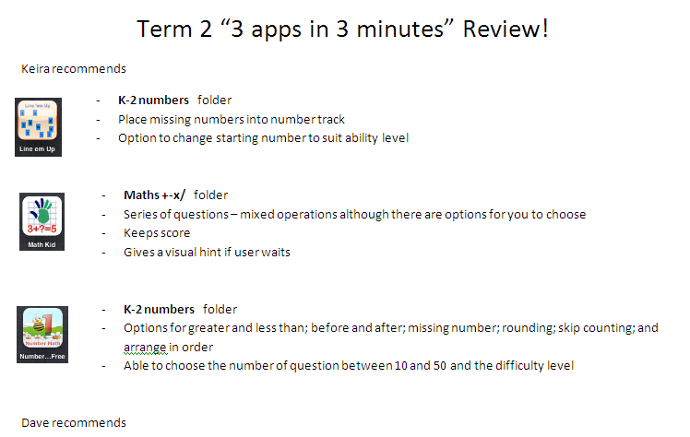
iPads in Education | 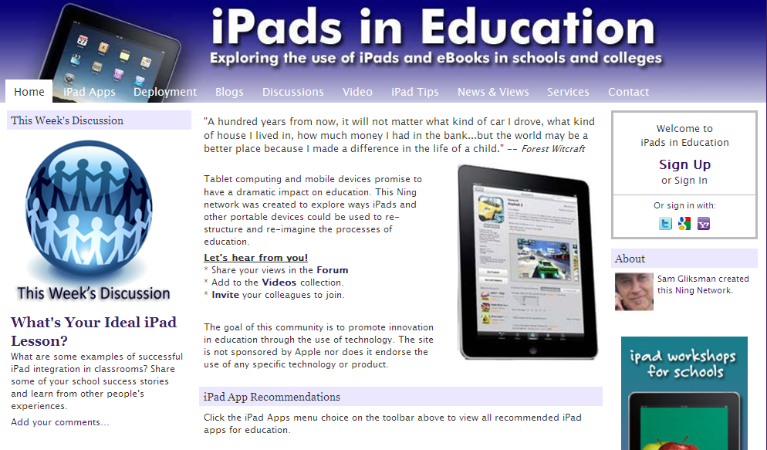
ICT with Miss C – Laura Chaffey’s site, laura is a classroom teacher at The Junction PS in Newcastle. | 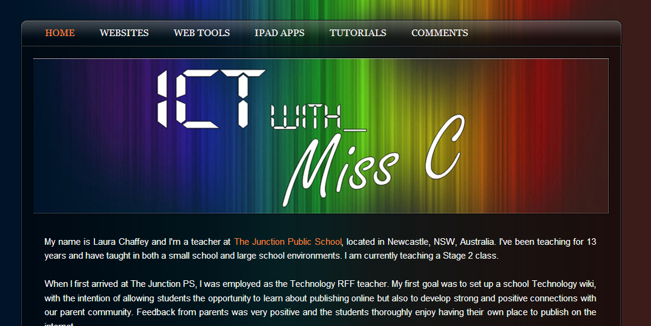
DEC Yammer – corporate social network. Excellent  iPad Group  https://www.yammer.com/tafe.nsw.edu.au  Join using your DEC login except with TAFE in place of DET eg. john.smith@tafe.nsw.edu.au | 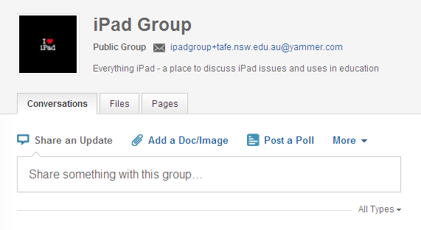
DEC Yammer – corporate social network  List of Apps Group  https://www.yammer.com/tafe.nsw.edu.au  Join using your DEC login except with TAFE in place of DET eg. john.smith@tafe.nsw.edu.au | 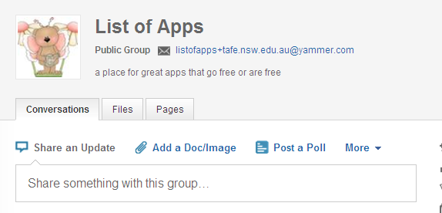
For reluctant writers try the iTalk app  Have students record their sentences prior to writing. | 

